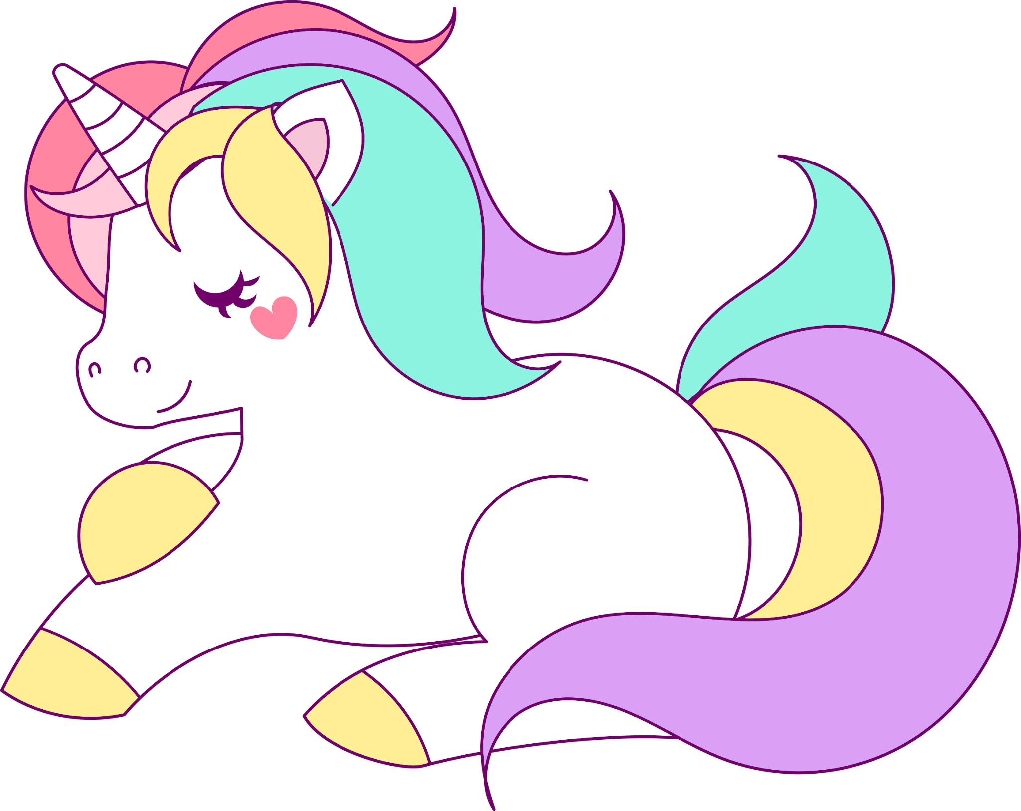 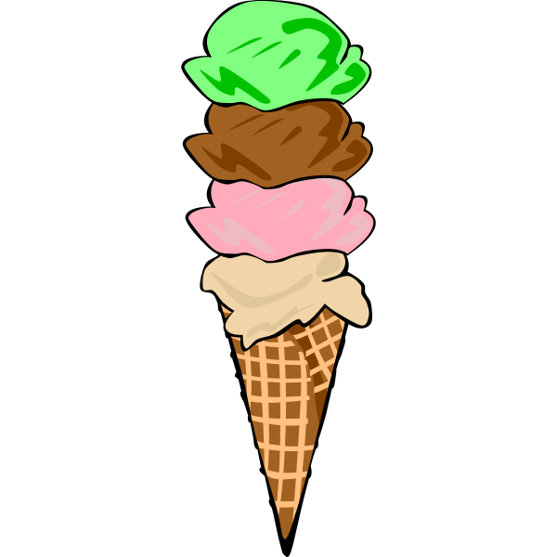

Happy Sunday!

Everyone had so much fun last week with Spirit Week! We loved seeing the kids and how they dressed. Thanks for helping your child participate in the fun.

This week we will learn and discuss our final letters of the alphabet. The letters are Uu, Ii, Cc, Xx and Kk. The students will make a Unique Unicorn, an Umbrella, I Icecream, an X-ray, C cat and a K Kangaroo, along with other projects and activities that correspond to these letters. . They will also be having homemade Ice Cream later this week!

On February 8th, from 9:00-10:00, we will have our “Someone

Special Saturday”. This is where Someone Special to your child (Mom, Dad, Grandparent, Aunt, Uncle etc.) can join us in class for one hour. We are asking that only ONE person join each child. During this hour, the children will sing you some songs, show you what happens during our regular class time, complete a project and have playtime with you and their favorite toys. It is a very special time for all.

I recently sent home a letter explaining our next Family Project of making a Valentine's Box for your child. Please let me know if you have any questions. We will be celebrating Valentine's Day on February 14th. **The children should not write each student's name.** They can just write sign their own name. There are 19 students in our class.

Thank you for all of your support and for sharing your amazing children that bring smiles and unconditional love every day :)

Take care, Donna

Important dates to remember:

February

6 & 7-Make-up pictures

8-“Special Someone” Saturday

14th-Valentines Day Celebration

17-21-Winter Recess (school closed)